# **Particle Swarm Optimization**

Particle swarm optimization (PSO) is one of the bio-inspired algorithms and it is a simple one to search for an optimal solution in the solution space. It is different from other optimization algorithms in such a way that only the objective function is needed and it is not dependent on the gradient or any differential form of the objective. It also has very few hyperparameters.

**INSPIRATION:**

a school of fish or a flock of birds that moves in a group “can profit from the experience of all other members”. In other words, while a bird flying and searching randomly for food, for instance, all birds in the flock can share their discovery and help the entire flock get the best hunt.

While we can simulate the movement of a flock of birds, we can also imagine each bird is to help us find the optimal solution in a high-dimensional solution space and the best solution found by the flock is the best solution in the space. This is a **heuristic solution** because we can never prove the real **global optimal** solution can be found and it is usually not. However, we often find that the solution found by PSO is quite close to the global optimal.

**LOGIC:**

Similar to the flock of birds looking for food, we start with a number of random points on the plane (call them **particles**) and let them look for the minimum point in random directions. At each step, every particle should search around the minimum point it ever found as well as around the minimum point found by the entire swarm of particles. After certain iterations, we consider the minimum point of the function as the minimum point ever explored by this swarm of particles

**ALGORITHM:**

Assume we have P particles and we denote the position of particle i at iteration t as Xi(t), which in the example of above, we have it as a coordinate Xi(t) = (xi(t), yi(t)). Besides the position, we also have a velocity for each particle, denoted as Vi(t) = (vxi(t), vyi(t). At the next iteration, the position of each particle would be updated as

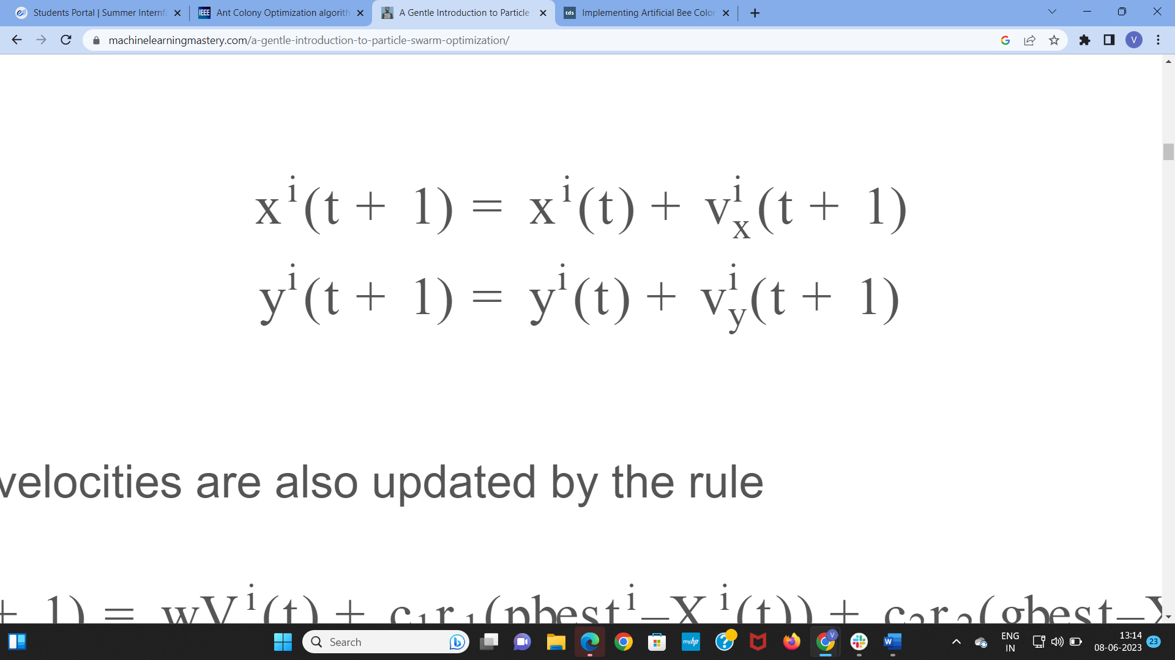

and at the same time, the velocities are also updated by the rule

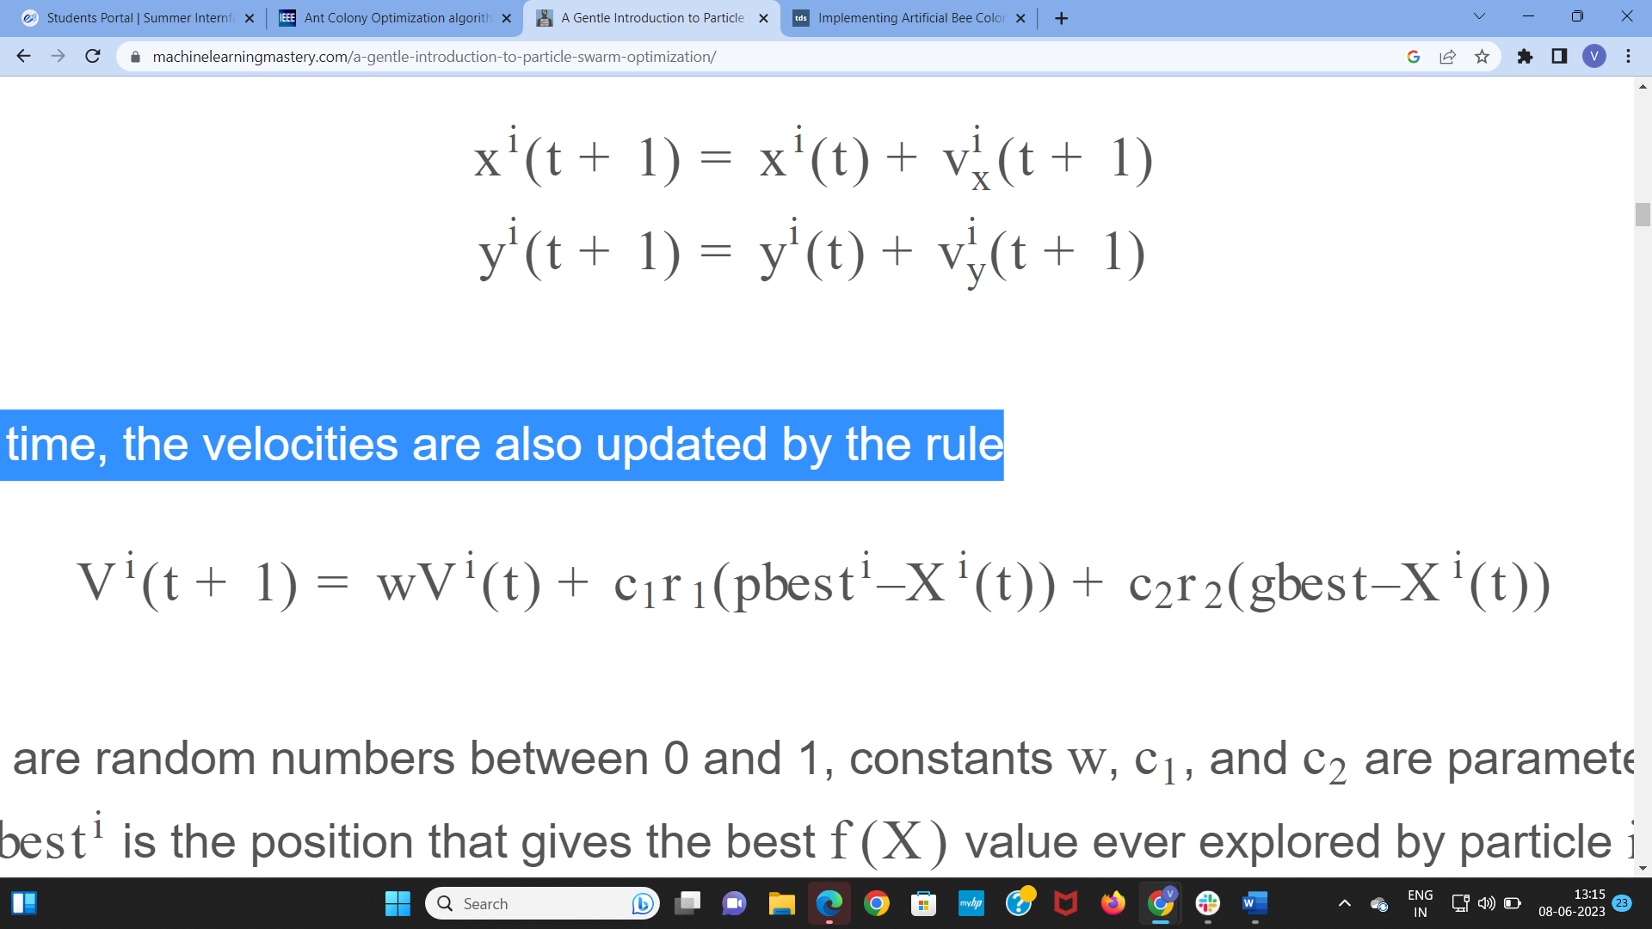

where r1 and r2 are random numbers between 0 and 1, constants w, c1, and c2 are parameters to the PSO algorithm, and pbesti is the position that gives the best

f(X) value ever explored by particle i and gbest is that explored by all the particles in the swarm.

We call the parameter w the inertia weight constant. It is between 0 and 1 and determines how much should the particle keep on with its previous velocity (i.e., speed and direction of the search). The parameters c1 and c2 are called the cognitive and the social coefficients respectively. They control how much weight should be given between refining the search result of the particle itself and recognizing the search result of the swarm. We can consider these parameters control the trade off between **exploration** and **exploitation**.

The positions pbesti and gbest are updated in each iteration to reflect the best position ever found thus far.

**PSUEDO CODE:**

